FOR IMMEDIATE RELEASE: June 14, 2018
ORPHANED BADGERS FIND A NEW HOME AT NORTHWEST TREK WILDLIFE PARK, TWO NEW SNOWY OWLS HAVE ARRIVED – AND BABY ANIMALS ABOUND
Bison and elk calves, deer fawns and a bighorn sheep lamb are roaming the meadows and forests, and visitors may see them during a tram ride through the Free-Roaming Area
EATONVILLE, Wash. –Just a few weeks ago, they were orphaned near Ellensburg. Their mother was killed by a car. And the two young badgers were being fed by a kindly landowner who worked to keep the foundlings alive until rescuers from the Washington Department of Fish & Wildlife could arrive.
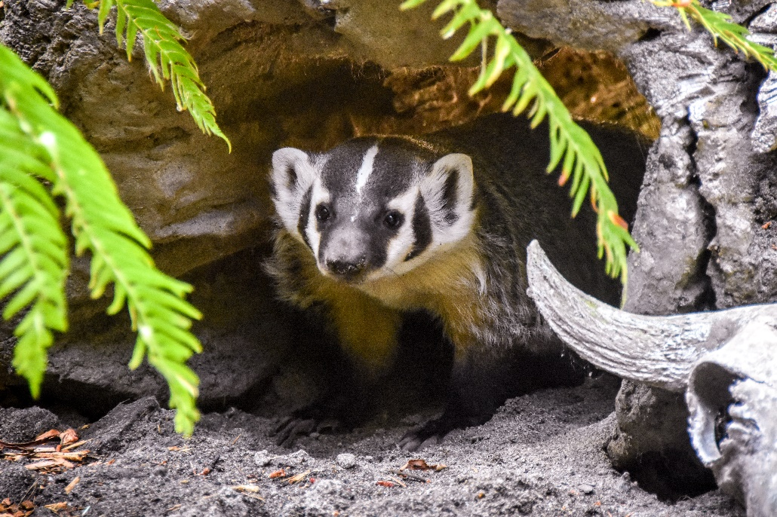
Today, badger sisters Poppy and Lavender, named for flowering Northwest plants, are at home in a new habitat at Northwest Trek Wildlife Park.
“They likely could not have survived in the wild and were in need of care and feeding when they were rescued,” Northwest Trek Zoological Curator Marc Heinzman said.
“We can ensure that they get the proper diet and provide them with a large outdoor habitat to explore, just as they would in the wild,” he added.
The two badger kits, estimated to be 2-3 months old, “are very outgoing and accustomed to people,” a fact perhaps related to the care they received from the landowner, Heinzman said.
They are on exhibit together in the Wetlands habitat at Northwest Trek and already are drawing large crowds.

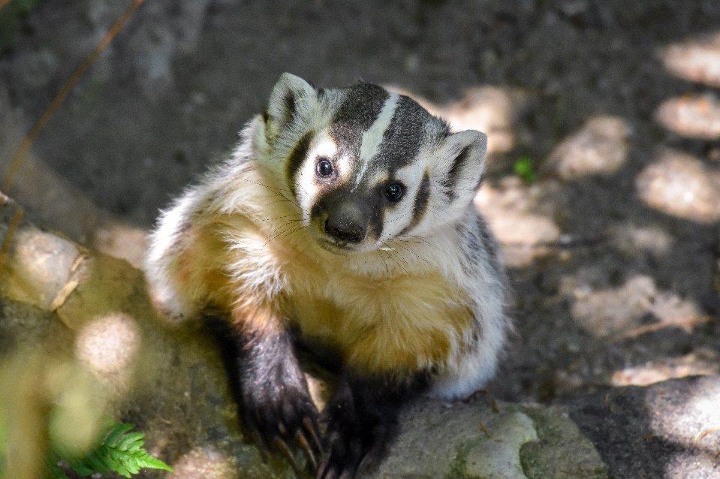
American badgers are members of the weasel family native to the Western North America, New England and parts of the Southeastern United States.
Their populations are increasingly threatened by loss of habitat and human-animal conflict.
In their new home at Northwest
Trek, Poppy and Lavender are
ambassadors for their species, helping guests learn more about these beautiful animals.

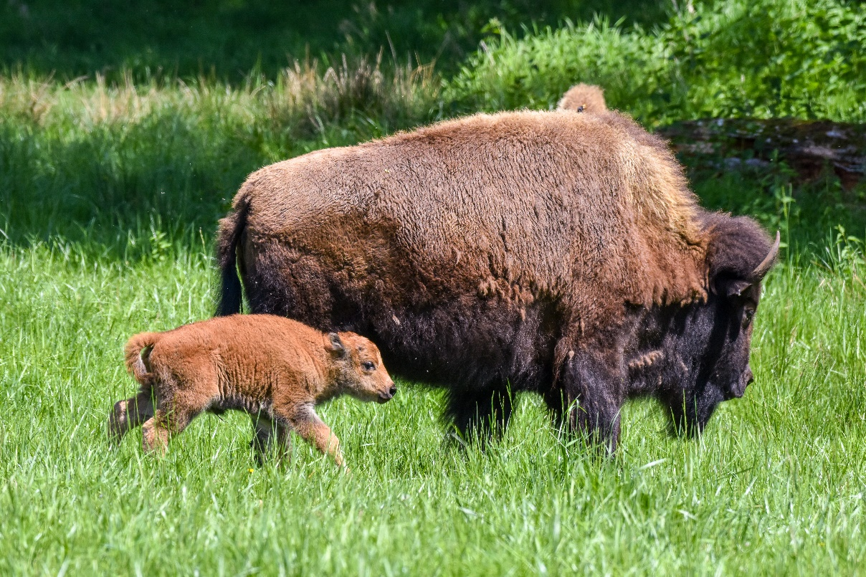
Newborns in the Free-Roaming Area
Meanwhile, out in Northwest Trek’s 435-acre Free-Roaming Area, in which bison, elk, moose, bighorn sheep, deer and other animals have the run of expansive meadows, lakes and forests, there is a great deal of new life this spring.
Some half a dozen bison calves, four elk calves (with more expected), several deer fawns, a bighorn sheep lamb and a gaggle of goslings may be spotted by visitors who take the 40-minute naturalist-narrated tour of the area aboard a comfortable tram. The Discovery Tram Tour is free with membership or admission to the wildlife park.
“Our guests really enjoy this time of year when they come and see the newborn animals,” said Education Curator Jessica Moore. “And our education staff is thrilled to be able to help visitors spot the calves and other newborns and learn more about the life cycles of these animals.”
And there is a lot to see. The bison calves, distinctive for the reddish-orange fur with which they’re born, will stick close to their moms for several weeks, nursing as they go. Slowly, they’ll gain more
independence and wander a bit farther from their moms – and their fur will begin to darken. Elk calves and deer fawns are born with spots but those gradually disappear as they age.
“Many guests tell us that they come back a few times during the spring and summer to watch the juveniles grow,” Moore said.
Snowy Owls
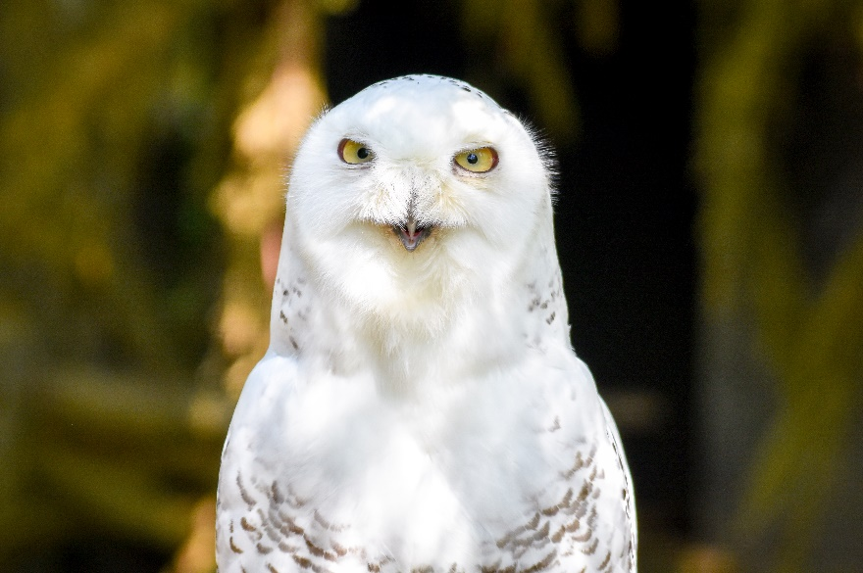
Brother and sister snowy owls Tundra and Taiga (pronounced Tie-ga) recently arrived from another Association of Zoos & Aquariums’ member zoo, where they were hatched last July. Tundra, the male, is already on exhibit and appears to be “super calm and comfortable around people,” Heinzman said. “He really quite quickly settled in.”
Keepers named the owls for the far northern latitudes where they spend their summers. Tundra is a northern region where the subsoil is permanently frozen. Taiga is a coniferous forest found in the high northern latitudes.
Though adult male snowy owls are generally completely white, Tundra still retains some of the brown and black bars on his plumage; they identify him as a juvenile.
Northwest Trek is open from 9:30 a.m. to 4 p.m. Mondays through Fridays and 9:30 a.m. to 5 p.m. on Saturdays and Sundays through June 29. On June 30, the park will shift to summer hours and be open from 9:30 a.m. to 6 p.m. daily. Visitors are allowed to remain in the wildlife park until 90 minutes after the admission gates close.
For more information, go to www.nwtrek.org.
###
Northwest Trek Wildlife Park, accredited by the Association of Zoos & Aquariums, is a 725-acre zoological park dedicated to conservation, education and recreation by displaying, interpreting and researching native Northwest wildlife and their natural habitats. The wildlife park is a facility of Metro Parks Tacoma and is located 35 miles southeast of Tacoma off State Highway 161.
Contacts
Kris Sherman, Northwest Trek Wildlife Park, 253-226-6718 or kris.sherman@pdza.org
Jeff Bernatowicz, Washington Department of Fish & Wildlife, 509-457-9304.
Photo credits: Northwest Trek Wildlife Park
Captions:
- Badger kit Poppy peers out from under a log in her habitat at Northwest Trek Wildlife Park.
- Orphaned badger kit Lavender in her new forested home at Northwest Trek Wildlife Park.
- Male snowy owl Tundra in his new habitat at Northwest Trek Wildlife Park.

